myCareer Adventure – IBM Cognitive Skillsbuild

Progress Report

Members: Manzo

Genete

Macatangay

Ebrada

Dionisio

Actual Screens:

Login

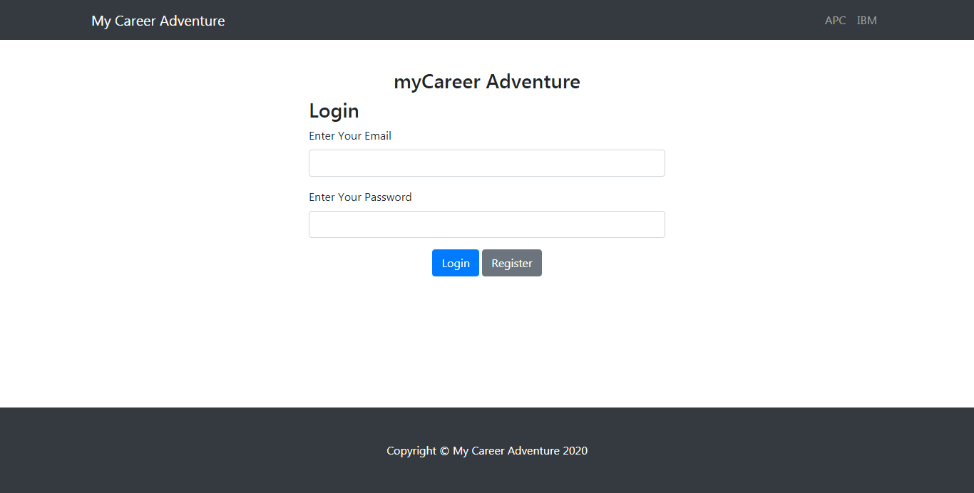

Register

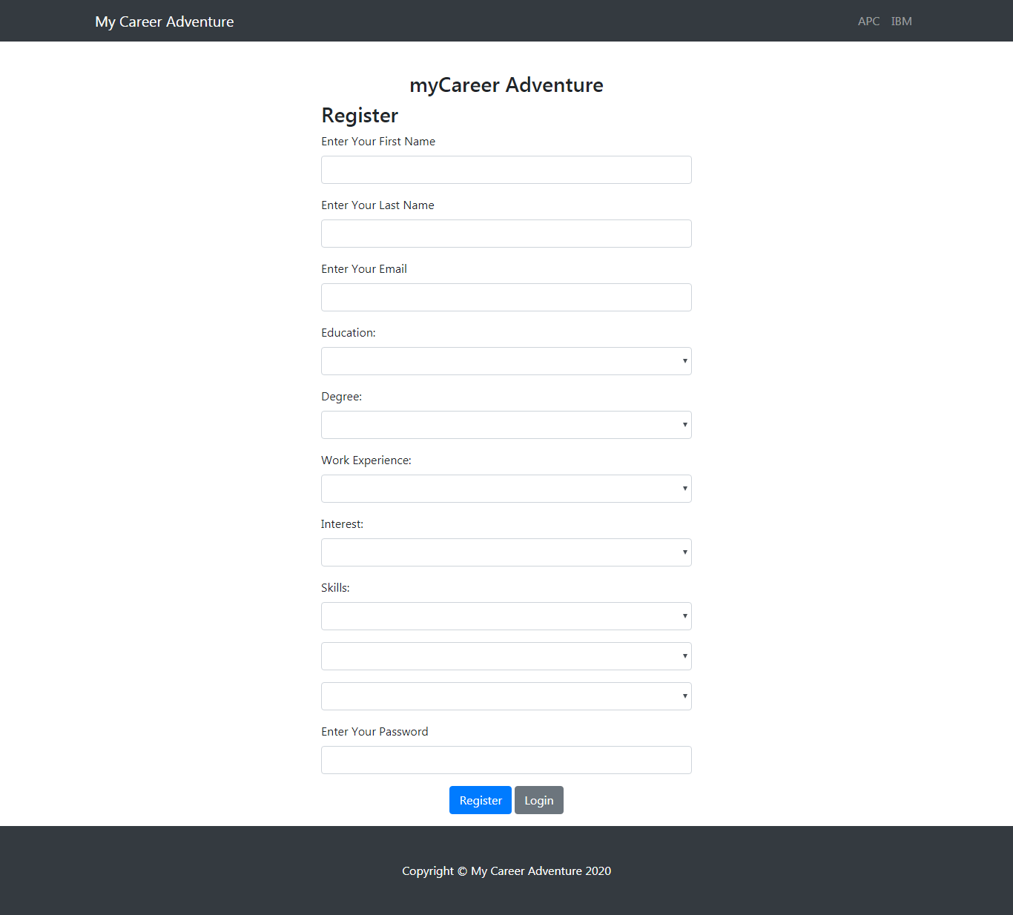

Full-Page Main

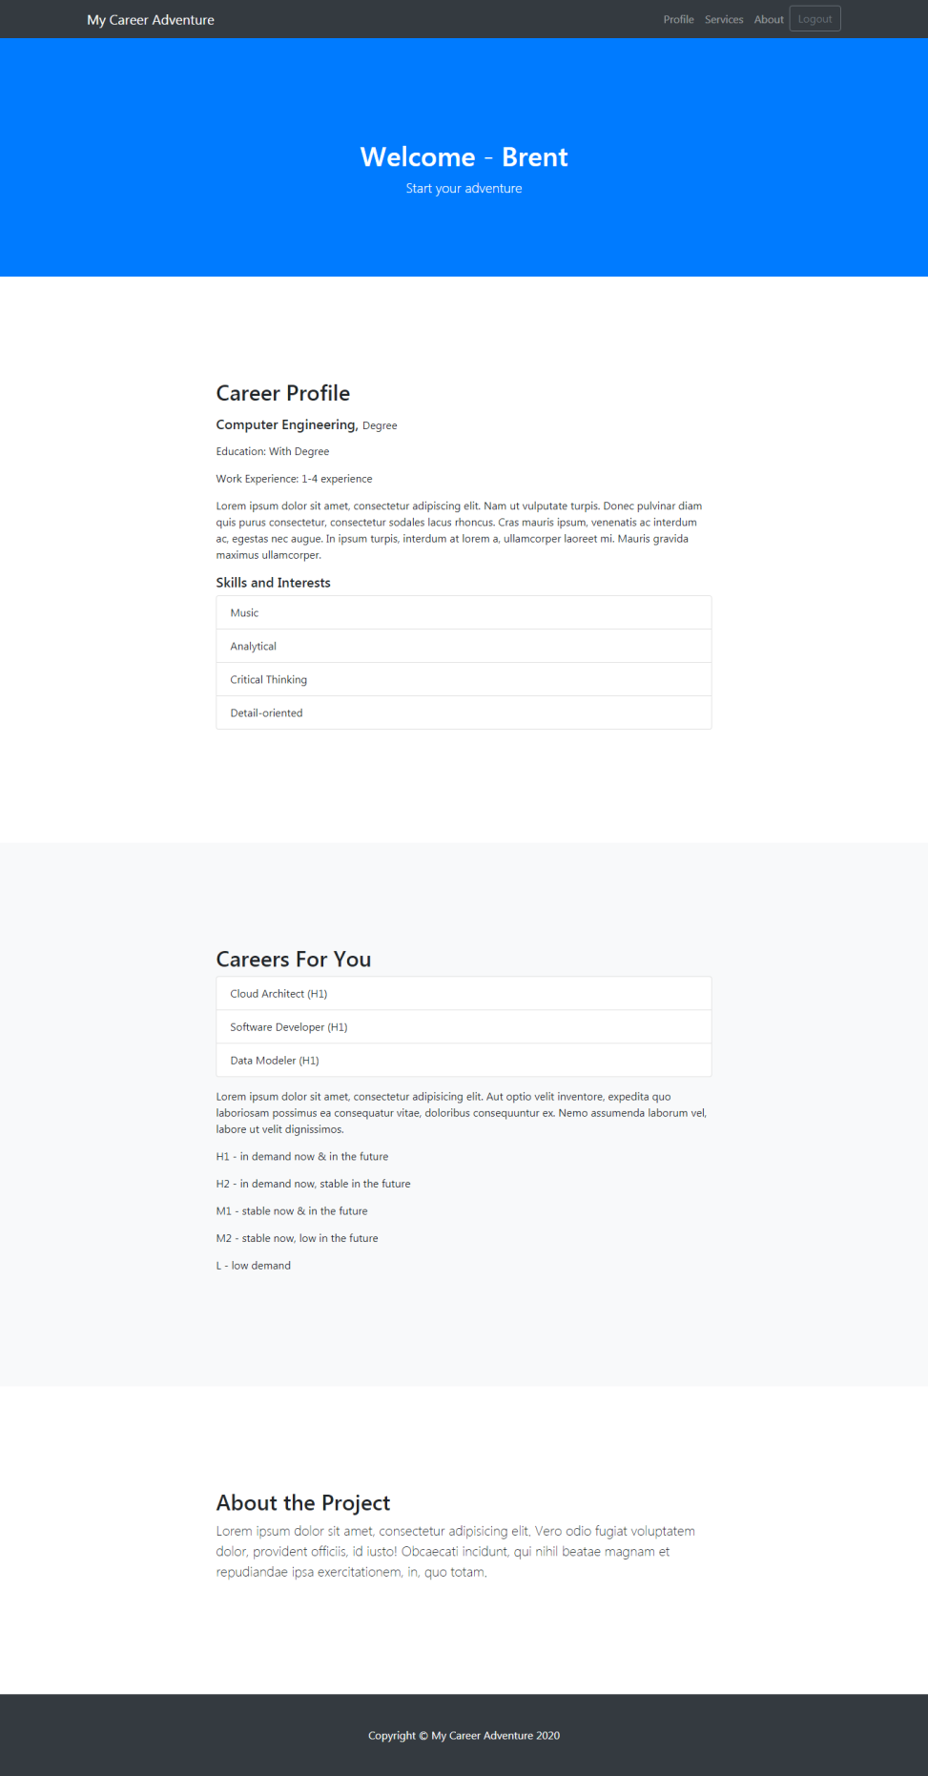

To-do:

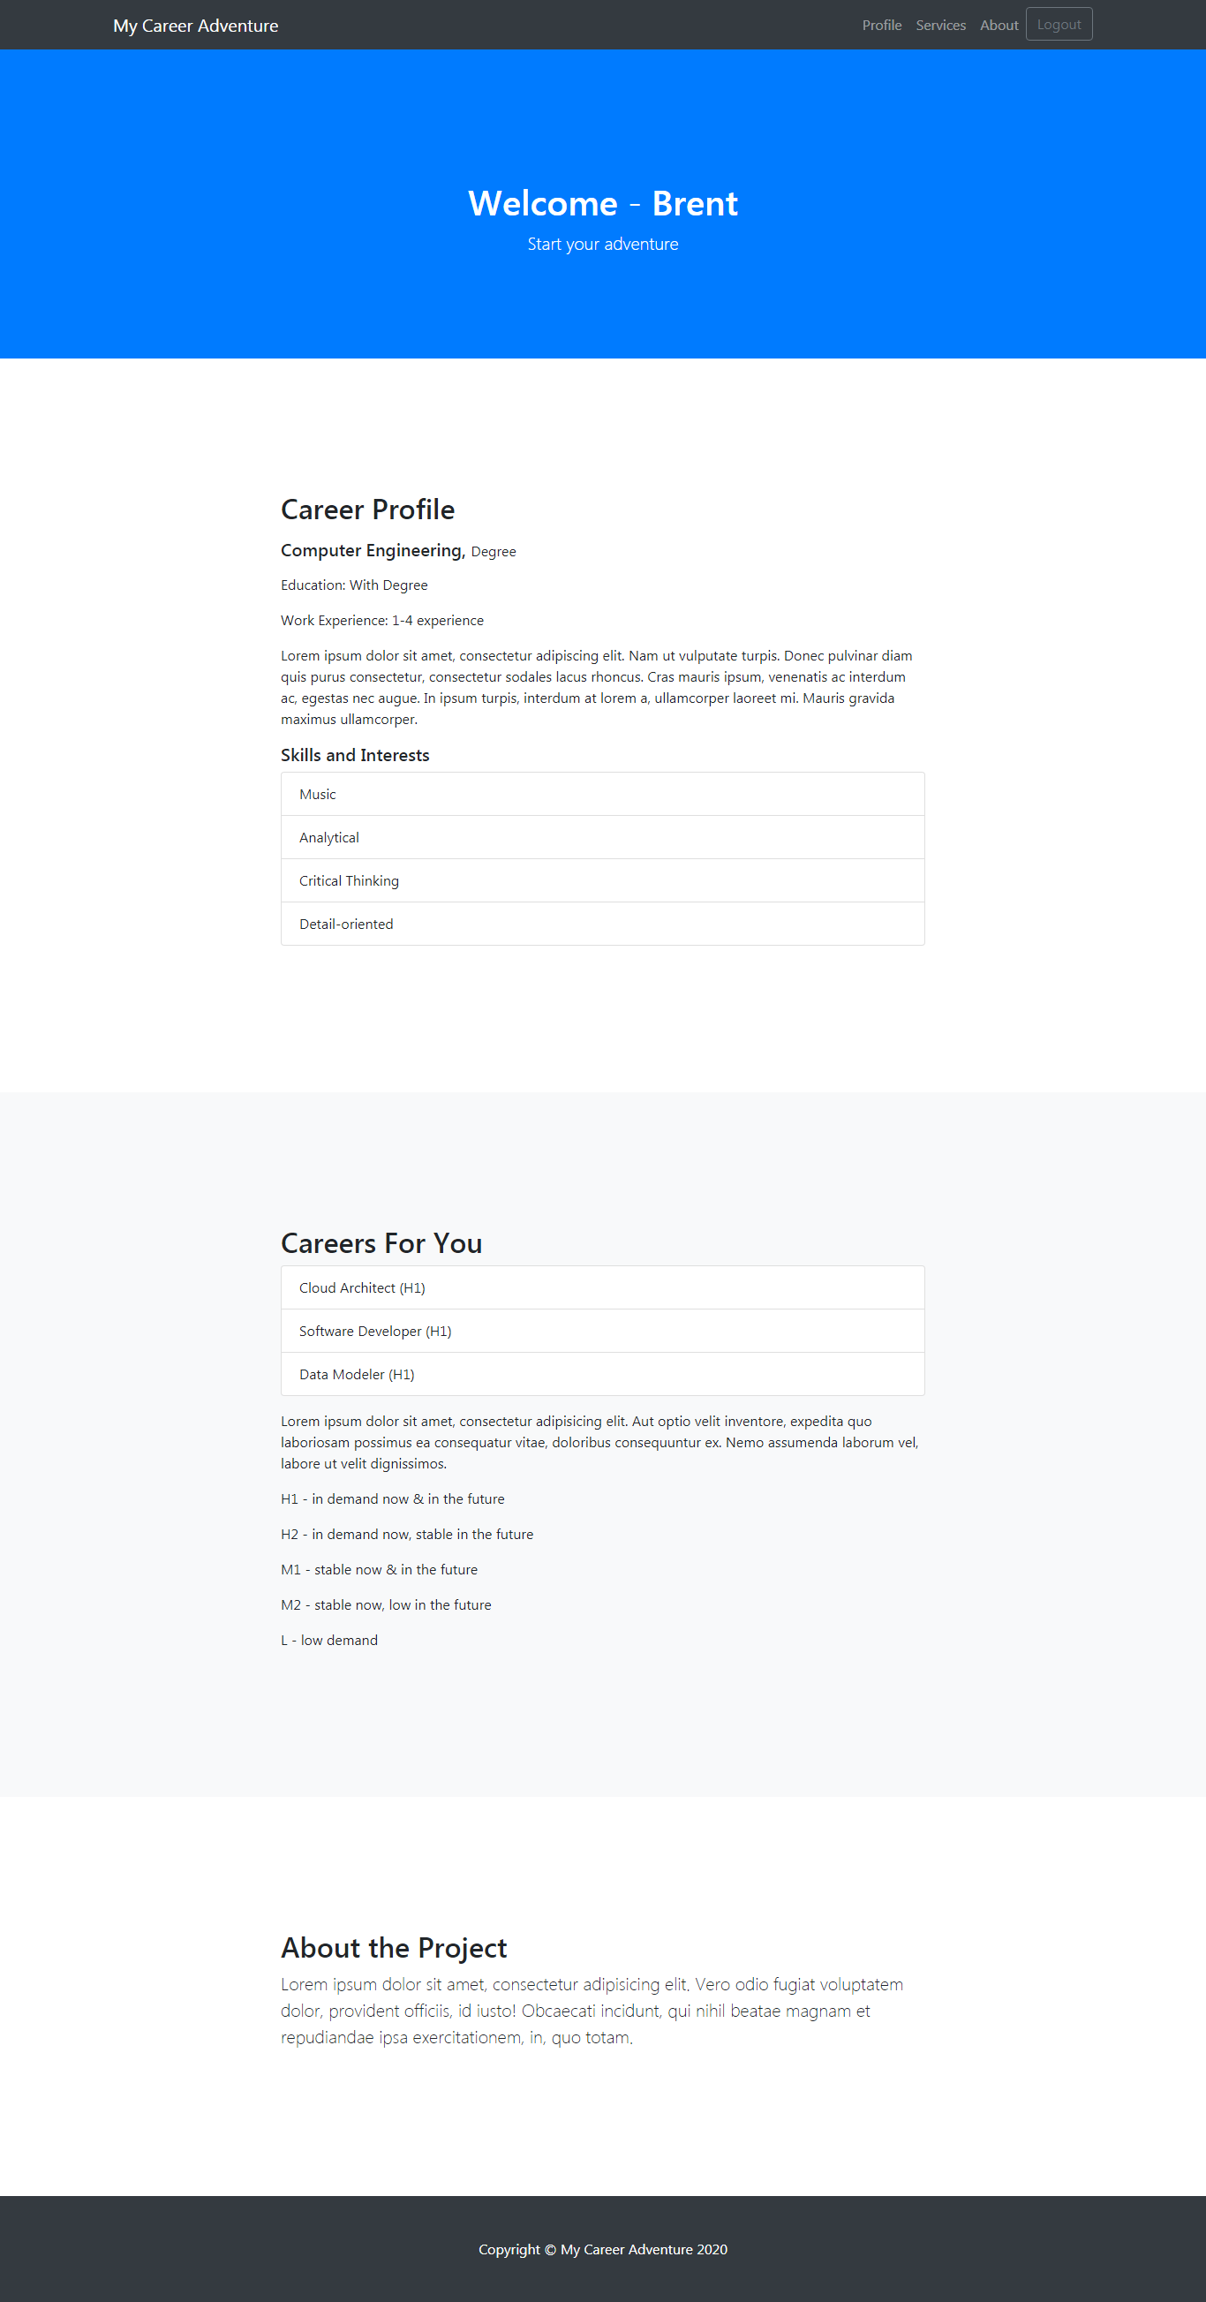

1. Project description
2. Details about how the app gives career suggestions and the labels beside each career.

3. Users with pre-determined info

User 1

First Name: ( )

Last Name: ( )

Email: ( )

Education:

Degree:

Work Exp:

Interest

Skill 1:

Skill 2:

Skill 3:

Password: (qwerty)

User 2

First Name: ( )

Last Name: ( )

Email: ( )

Education:

Degree:

Work Exp:

Interest

Skill 1:

Skill 2:

Skill 3:

Password: (qwerty)

User 3

First Name: ( )

Last Name: ( )

Email: ( )

Education:

Degree:

Work Exp:

Interest

Skill 1:

Skill 2:

Skill 3:

Password: (qwerty)

User 4

First Name: ( )

Last Name: ( )

Email: ( )

Education:

Degree:

Work Exp:

Interest

Skill 1:

Skill 2:

Skill 3:

Password: (qwerty)

User 5

First Name: ( )

Last Name: ( )

Email: ( )

Education:

Degree:

Work Exp:

Interest

Skill 1:

Skill 2:

Skill 3:

Password: (qwerty)

User 6

First Name: ( )

Last Name: ( )

Email: ( )

Education:

Degree:

Work Exp:

Interest

Skill 1:

Skill 2:

Skill 3:

Password: (qwerty)

4. IBM Tool Integration

- Watson Knowledge

- Watson Discovery

5. Project Logo - My Career Adventure Logo